www.researchideas.ca/wmt 2016

THE SUM OF QUARTER HOURS ON A CLOCK

Let's complete an addition table for quarter hours on a clock.

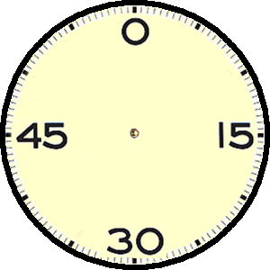

Make a prediction before you complete the table: how many different answers are possible?
 | 0 | 15 | 30 | 45
0 | 0 | 15
15 | 15 |  |  | 0
30 |  |  |  | 15
45

