www.researchideas.ca/wmt 2016

THE SUM OF HOURS ON A CLOCK

Let's complete an addition table for hours on a 12-hour clock.
We'll use 0 for 12, so the hours we'll add will be: 0, 1, 2, 3, 4, 5, 6, 7, 8, 9, 10 and 11.

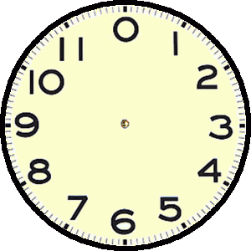

Make a prediction before you complete the table: how many different answers are possible?
 | 0 | 1 | 2 | 3 | 4 | 5 | 6 | 7 | 8 | 9 | 10 | 11
0 | 0 | 1 | 2
1 | 1 | 2 | 3
2 | 2 | 3 | 4
3
4
5
6
7
8
9
10 |  |  |  | 1
11 |  |  |  | 2

